

PROJECT REPORT ON

**I-School E-Learning-app)**

FOR

**MES Institute of Management & Career Courses (IMCC)**

SUBMITTED TO

**SAVITRIBAI PHULE PUNE UNIVERSITY**

UNDER THE GUIDANCE OF

**Dr. Ravikant Zirmite**

SUBMITTED BY

**Ravi kumar jha**

**SAVITRIBAI PHULE PUNE UNIVERSITY MASTER IN COMPUTER APPLICATION MAHARASHTRA EDUCATION SOCIETY’s**

**INSTITUTE OF MANAGEMENT AND CAREER COURSES (IMCC), PUNE-411038**

**2022-23**



**Institute of Management & Career Courses (IMCC)**

**Approved by AICTE and Recognized by Savitribai Phule Pune University, Pune**

**NBA Accredited MCA Program (Valid up to 30.06.2022)**

IMCC Campus, 131, Mayur Colony, Kothrud, Pune 411038, Maharashtra, India

Ph.: 020-2546 3453 / 6271 / 73 | e-mail: [info.imc](mailto:info.imcc@mespune.in)[c@mespune.i](mailto:c@mespune.in)n

**Ref. No. MES IMCC / 006-A/2022-23/ Date: / /**

CERTIFICATE

This is to certify that the Project Report entitled

## " I-School (E-Learning-app )”

is prepared by

# Ravi kumar jha

M.C.A. Semester VI Course for the Academic Year 2021-22 at M.E. Society's Institute of Management & Career Courses (IMCC),

M.C.A Course is affiliated to Savitribai Phule Pune University

To the best of our knowledge, this is original study done by the said student and important sources used by him have been duly acknowledged in this report.

The report is submitted in partial fulfillment of M.C.A Course for the Academic Year 2021-22as per the rules and prescribed guidelines of Savitribai Phule Pune University.

**Dr. Ravikant Zirmite**



Head, Dept of MCA MES IMCC

Head Office: 'MES Bhavan', 1214-1215, Sadashiv Peth,

Pune - 411030,

Maharashtra, India.

**Dr. Santosh Deshpande**

Director, MES IMCC

**CERTIFICATE**

This is to certify that **Ravi kumar jha *has*** completed the project work entitled **“*I school (E-Learning-app)”*** under my guidance. The report is submitted in partial fulfillment of

M.C.A. Course for the Academic Year 2021-2023 as per the rules & prescribed guidelines of Savitribai Phule Pune University.

His work is found to be satisfactory and complete in all respects.

**Dr .RaviKant Zirmite  
 (Internal Project Guide)**

Acknowledgement

I am very glad to take this opportunity to acknowledge all those who helped me in designing, developing and successful execution of my Project **“I-School (Online Photo Frame Shop)”.**

I would like to extend my thanks and gratitude to my project guide **Dr. Ravikant Zirmite**

(Assistant Professor, IMCC) and **Sourav** for his valuable guidance and timely assistance throughout the development of this project.

I would also like to extend my thanks and gratitude to **Dr. Santosh Deshpande** (Director, MES’ IMCC), **Dr. Manasi Bhate** (Deputy Director, MES' IMCC) and **Dr. Ravikant Zirmite** (HOD-MCA, MES' IMCC) for their constant help and support.

Last but not the least, I would like to thank all the teaching and nonteaching faculties for their cooperation.

- Dhruv vats

**INDEX**

|  |  |  |  |
| --- | --- | --- | --- |
| **Sr.**  **No.** |  | **Name of Topic** | **Page No.** |
| 1 |  | **Chapter 1: Introduction** |  |
| 1.1 | Institute Profile | 1 |
| 1.2 | Abstract | 4 |
| 1.3 | Existing System and Need for System | 6 |
| 1.4 | Scope of System | 9 |
| 1.5 | Operating Environment - Hardware and  Software | 11 |
| 1.6 | Brief Description of Technology Used | 12 |
| 2 |  | **Chapter 2: Proposed System** |  |
| 2.1 | Study of Similar Systems | 16 |
| 2.2 | Feasibility Study | 20 |
| 2.3 | Objectives of Proposed System | 22 |
| 2.4 | Users of System | 24 |
| 3 |  | **Chapter 3: Analysis and Design** |  |
| 3.1 | System Requirements | 25 |
| 3.2 | Entity Relationship Diagram | 28 |
| 3.3 | Table Structure | 29 |
| 3.4 | Use Case Diagrams | 34 |

|  |  |  |  |
| --- | --- | --- | --- |
|  | 3.5 | Class Diagram | 37 |
| 3.6 | Activity Diagram | 38 |
| 3.7 | Deployment Diagram | 40 |
| 3.8 | Module Hierarchy Diagram | 41 |
| 3.9 | Sample Input and Output Screens | 42 |
| 4 |  | **Chapter 4: Coding** |  |
|  | 4.1 | Code snippets | 54 |
| 5 |  | **Chapter 5: Testing** |  |
| 5.1 | Test Strategy | 59 |
| 5.2 | Unit Test Plan | 60 |
| 5.3 | Acceptance Test Plan | 60 |
| 5.4 | Test Cases | 61 |
|  |  |  |
| 6 |  | **Limitation of Proposed System** | 67 |
| 7 |  | **Proposed Enhancement** | 68 |
| 8 |  | **Conclusion** | 69 |
| 9 |  | **Bibliography** | 70 |
| 10 |  | **User Manual** | 71 |

**INTRODUCTION:**

* 1. **Institute Profile :**

Institute of Management and Career Courses (IMCC) is a premier Management Institute, established in 1983 by Maharashtra Education Society (MES) for providing quality education and technical expertise at the Post Graduation Level in the Fields of Computers and Management. The Institute is recognized by SPPU under Section 46 of Pune University Act, 1974 and Section 85 of Maharashtra University Act, 1994 and Approved by AICTE New Delhi to conduct MCA and MBA programs. The Institute is located at 131, Mayur Colony, Kothrud, Pune-411038 having 30,000sq.ft. built area & totally independent campus.

IMCC is recognized as a Ph.D. Research Center under the Faculty of Management, SPPU. IMCC has 38 years standing & it is well-known for its conducive educational atmosphere. IMCC focuses on the all-round development of its students. Thus, apart from excellence in academics, students develop their inner potential by way of active participation in co- curricular & extra-curricular activities. IMCC has developed excellent rapport with Industry by way of

Guest Lectures, Seminars, Workshops, Industrial

Visits & Placements. The main motto of the Institute is to instill the concepts of total personality development in the students. The emphasis is laid on ‘Teacher Disciple Relationship’ in place of ‘Boss Subordinate’ relationship at their assignment

The preamble of IMCC “FACTA-NON-VERBA'' lucidly means that the Institute produces the new breed of professionals, who’s deeds will speak and there could be no requirement of pomposity. The zooming enthusiastic, rational and excellent external endeavors are being imbibed in the students to prove their mettle. The conducive milieu of the Institute molds the budding managers to reveal in managing flexibility, integration, change and transformation. These ‘would be’ professionals are channelized in such a way to ‘orchestrate’ and deploy business and technological management skills in a synergistic manner to grab the tangible success. The faculty members put their relentless efforts in educating the students to synthesize business management acumen and technology insights in a creative manner.

# ABSTRACT :

I-SCHOOL:

I-School (E-Learning Management System) is a project which aims in developing an online application to provide Online Education, maintain Study Materials, keep Student records and collect Payments. This project has login features, Educator as Admin and Student as an user can login into their own portal separately. The Admin can login, through which the admin can monitor the whole system. This System can be used to search for course, add new courses, edit course, check payment status etc. The Admin after logging into his account can generate reports such as sell Report. The User can login into his account to follow course he purchased and can share his/her feedback.

Overall this project of ours is being developed to help the Educator (Admin) as well as Students (User) to provide Teaching-Learning platform in the best way possible.

For educators, I-School offers an array of powerful tools to streamline their teaching process. Administrators can effortlessly search for courses, enabling them to curate a diverse and engaging curriculum. Additionally, they have the ability to add new courses, edit existing ones, and maintain a repository of study materials. This centralized approach simplifies content management and ensures that educators can easily organize and update their course materials.

Moreover, I-School includes a robust payment system that facilitates secure and convenient transactions. Students can make payments for the courses they wish to enroll in, ensuring a seamless registration process. The system also allows administrators to track payment statuses, providing them with a comprehensive overview of financial transactions within the platform.

Overall, I-School is a cutting-edge project developed to revolutionize online education and enhance the teaching-learning experience. By leveraging its comprehensive features, educators can efficiently manage their courses, while students benefit from a user-friendly platform that offers a wealth of study materials and fosters interactive learning. I-School aims to create an optimal teaching-learning environment, transforming the way education is delivered and accessed in the modern era.

# EXISTING SYSTEM AND NEED FOR SYSTEM :

## NEED FOR SYSTEM

A flexible web-based learning experience allows you to go through a guided curriculum or choose lessons on an as-needed basis.

Following are the main objectives: -

* Ability to recall previously learned material – Students/learners can watch video courses as many times as they need. If they forgot something during the course they can come back and watch that specific part anytime.
* Creative way to present lesson – It is very creative way to present lectures. It will surely enhance teaching ability of tutor.
* Low Cost – As nobody needs to travel or rent anything so it’s very cost efficient.
* High Quality – As tutor do not has time boundation so he can teach in his own comfort time.
* Learn anytime from anywhere – Students/Learners can start learning anytime from anywhere they just required internet connection with a compatible device.
* Improve course quality according to learner’s feedback – Tutor can improve their course as per student’s feedback. It will help tutor to improve their ability to teach.
* Earn Money Online– As courses are paid so we can say it’s an online teaching business which has no boundaries means students/learners can join from across the world so this system can make good business with good quality.

# SCOPE OF SYSTEM

1. Online Education: The system aims to provide a platform for online education, enabling students to access courses and study materials remotely. This opens up opportunities for individuals who may not have easy access to traditional educational institutions.
2. Study Material Management: I-School facilitates the organization and maintenance of study materials. Educators can upload and manage course materials, making it convenient for students to access relevant resources and enhance their learning experience.
3. User Login and Personalized Portals: The project includes a secure login system that allows educators and students to access their respective portals. This ensures a personalized experience for each user, with tailored functionalities and access to relevant features.
4. Administrator Monitoring: The system provides administrators with comprehensive monitoring capabilities. Educators can oversee the entire system, track student progress, manage course enrolments, and generate reports to gain insights into the overall performance of the platform.
5. Course Management: Educators can add new courses, edit existing ones, and search for specific courses within the system. This feature enables efficient course organization and allows educators to adapt their offerings to meet the needs of their students.
6. Payment System: I-School includes a secure payment system that enables students to make payments for the courses they wish to enrol in. Administrators can track payment statuses, ensuring a smooth registration process and facilitating financial management.
7. Reporting and Analytics: The system generates reports that provide valuable insights into course enrolments, revenues, and other financial aspects. These reports assist administrators in making data-driven decisions, improving course offerings, and optimizing the platform's performance.
8. Feedback and Interaction: I-School encourages student engagement through features that enable feedback sharing and interaction. Students can provide feedback on courses, fostering a collaborative learning environment and allowing educators to continuously improve their teaching methods.
9. Teaching-Learning Platform: The primary objective of the I-School project is to create an effective teaching-learning platform. It aims to enhance the educational experience for both educators and students, offering a user-friendly interface, comprehensive resources, and features that facilitate effective knowledge transfer

# OPERATING ENVIRONMENT- HARDWARE AND SOFTWARE

**HARDWARE REQUIREMENT:**

**5.1 Hardware Requirements**

|  |  |
| --- | --- |
| Processor | 1.6 GHz or Faster Processor |
| RAM | 4 GB |
| Disk Space | 10 GB of Available Hard Disk |
| Graphic | DirectX 9-Capable Video Card |
| Display | 1024 X 768 or Higher Resolution |

# SOFTWARE REQUIREMENT:

|  |  |
| --- | --- |
| Operating System | Windows 11 |
| Front End | HTML, CSS, JavaScript |
| Back End | PHP |
| Library/ Framework | Bootstrap, jQuery, Font Awesome |
| Plugins | Owl Carousel |
| Code Editor | Visual Studio Code 1.33 |
| Database | MySQL |
| Web Server | Apache |
| Web Browser | Google Chrome |
| Payment Gateway | PayPal |
| Drawing Tools | yEd Graph Editor |
| StarUML |

# BRIEF DESCRIPTION OF TECHNOLOGY USED:

**6.1 PHP**

PHP is an open-source language and all its components are free to use and distribute. PHP is server-side scripting language. It is embedded in HTML source code. PHP supports all major web servers such as Apache, Microsoft IIS and Netscape etc. All the major database such as MySQL, PostgreSQL, Oracle, Sybase, Microsoft SQL Server is supported by PHP. Following are some major advantages: -

* Friendly With HTML - PHP and HTML are interchangeable within the page. You can put PHP outside the HTML or inside.
* Interactive Features - PHP allows you to interact with your visitors in ways HTML alone can't.
* Top-Notch Online Documentation - The PHP documentation is the best on the web. Hands down.
* Compatible With Databases - A good benefit of using PHP is that it can interact with many different database languages including MySQL.

# OPERATING SYSTEMS USED:

· Windows Operating System

# DATABASE:

**6.2 MySQL:**

MySQL is the most popular open-source relational database management system. It is one of the best RDBMS being used to develop web-based applications. It is easy to use and fast RDBMS. Following are the top reason to use MySQL: -

* High Performance
* Robust Transactional Support
* Strong Data Protection
* Open-Source Freedom

1. **PROPOSED SYSTEM:**
   1. **Study of Similar Systems:**

**Coursera**

Coursera is an online learning platform that offers a wide range of courses and educational programs from top universities and institutions around the world. It provides users with the opportunity to enrol in courses covering various subjects, including technology, business, arts, science, and more.

Similar to iSchool, Coursera allows students to search for courses based on their interests, enroll in courses of their choice, and access course materials such as video lectures, readings, and assignments. It offers a user-friendly interface that facilitates learning at one's own pace and provides interactive quizzes and assessments to enhance the learning experience.

Coursera also offers certification programs and degree programs in partnership with universities, allowing students to earn recognized credentials and degrees through online learning. It provides a platform for users to track their progress, participate in discussion forums, and interact with instructors and fellow learners.

# Feasibility Study

The purpose of the feasibility study is not to solve the problem, but to determine if the problem is worth solving. This helps to decide whether to proceed with the problem or not. It involves the analysis of the problem & collection of all relevant information relating to the product. The feasibility study concentrates on the following, such as Technical Feasibility, Economic Feasibility, and Operational Feasibility.

# Technical Feasibility:

Student can view different categories of photo frames and can buy them using the website which is developed using the technology PHP Mysql and hence the project is technically feasible.

# Economical Feasibility:

Economic feasibility evaluates the financial aspects of developing and maintaining the school system. It involves analyzing the costs involved and the potential benefits or return on investment. Key considerations for economic feasibility include:

cost and efforts involved in maintaining the registers, books, files, and generation of various reports. The system also reduces the administrative and technical staff to do various jobs that single software can do. So, this system is economically feasible.

# Operational Feasibility:

The Student are using different types of peripheral devices. Our system provides a user-friendly interface for all devices (Like laptops, mobile phones).

The student can view various courses available and enable registered users to purchase desired Coursesinstantly using different payment methods and also can place an order by using the UPI and on Paypal Payment option. This project provides easy access to Administrators and Managers to view orders placed.

# Objectives of Proposed System

A flexible web-based learning experience allows you to go through a guided curriculum or choose lessons on an as-needed basis. Following are the main objectives:-

* Ability to recall previously learned material – Students/learners can watch video courses as many times as they need. If they forgot something during the course they can come back and watch that specific part anytime.
* Creative way to present lesson – It is very creative way to present lectures. It will surely enhance teaching ability of tutor.
* Low Cost – As nobody needs to travel or rent anything so it’s very cost efficient.
* High Quality – As tutor do not has time boundation so he can teach in his own comfort time.
* Learn anytime from anywhere – Students/Learners can start learning anytime from anywhere they just required internet connection with a compatible device.
* Improve course quality according to learner’s feedback – Tutor can improve their course as per student’s feedback. It will help tutor to improve their ability to teach.
* Earn Money Online– As courses are paid so we can say it’s an online teaching business which has no boundaries means students/learners can join from across the world so this system can make good business with good quality.

# Users of System

## In this system, there will be two users.

## USER (Student):

## 

## 

## Course Search: Students can search for courses based on their interests, subject areas, or specific keywords. The system should provide a search functionality that allows students to easily discover and explore available courses.

## Course Enrolment: After finding a desired course, students should be able to enrol in the course. The system should provide a straightforward enrolments process, where students can confirm their enrolments and receive a confirmation of successful enrolments.

## Lesson Access: Once enrolled in a course, students should have access to the lessons and study materials associated with that course. The system should provide a user-friendly interface where students can navigate through lessons, view videos or presentations, access documents, and participate in quizzes or assessments.

## ADMIN:

## Admin Tasks:

## Course Management: The admin has the authority to manage courses within the system. This includes adding new courses, editing existing courses, and deleting courses if necessary. The admin should have access to a course management interface that provides options for adding, editing, and deleting course information.

## Lesson Management: Admins can also manage individual lessons within courses. They have the ability to add new lessons, edit existing lessons, and remove lessons as needed. The system should provide an interface where admins can easily manage and organize course content.

## Course Search and Filtering: Admins should have the capability to search for specific courses within the system. The search functionality can help admins locate courses based on various parameters such as course name, subject, or instructor. Filtering options can be provided to narrow down search results.

## User Management: Admins can manage user accounts within the system. This includes functionalities such as creating new user accounts, modifying user information, and deactivating or deleting user accounts if required. The system should provide an interface for admins to perform these user management tasks

1. **Analysis and Design**
   1. **System Requirements**

# Functional requirements

1. User Registration and Login: The system should allow users (educators and students) to register and create their accounts. It should also provide a secure login mechanism to access the respective portals.
2. Course Management: The system should enable educators to add new courses, edit existing courses, and organize them into appropriate categories. Educators should also be able to upload study materials and multimedia content related to each course.
3. Course Search and Enrolment: Students should be able to search for courses based on their interests, view course details, and enrol in their preferred courses. The system should handle the enrolment process and provide confirmation to students upon successful enrolment.
4. Feedback and Rating: Students should be able to provide feedback and ratings for the courses they have completed. The system should capture this feedback and make it available to educators for continuous improvement.
5. Payment Processing: The system should support secure payment processing for course fees. It should integrate with popular payment gateways to handle transactions smoothly and provide payment confirmation to students.

Admin can view, edit, update, delete Courses , Lessons categories, and orders.

1. Prepare Reports:

Admin can view reports for courses, lessons, Students , etc.

1. Payment:

In this website the Studentcan make online payment using PayPal, card or UPI

# Non Functional requirements

Following Non-Functional Requirements will be there in the insurance to the internet:

1. Secure access to consumer’s confidential data.
2. 24X7 availability.

Non-Functional Requirements define system properties and constraints. Various other Non-Functional Requirements are: Security, Reliability, Maintainability, Portability, Extensibility, Reusability Compatibility, Resource Utilisation

Performance Requirements:

Increase StudentSatisfaction I-School website must allow Studentsto access services 24 hours a day.

Security Requirements: We understand that there is nothing more important than knowing that transactions are private and secure. Therefore, we have applied the very latest in technology when creating the I-School website security architecture.

* 1. **Entity Relationship Diagram (ERD)**

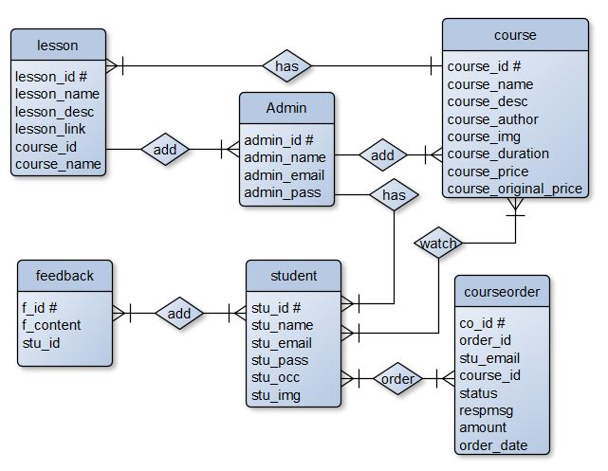

# Table Structure

## Admin (Stores admin detail )

|  |  |  |
| --- | --- | --- |
| **Attribute** | **Data Type** | **Description** |
| admin_id # | int(11) | Stores Admin ID |
| admin_name | varchar(255) | Stores Admin Name |
| admin_email | varchar(255) | Stores Admin Email ID |
| admin_pass | varchar(255) | Stores Admin Password |

1. **Student**

|  |  |  |
| --- | --- | --- |
| **Attribute** | **Data Type** | **Description** |
| stu_id # | int(11) | Stores student ID |
| stu_name | varchar(255) | Stores student Name |
| stu_email | varchar(255) | Stores student Email ID |
| stu_pass | varchar(255) | Stores student Password |
| stu_occ | varchar(255) | Stores student occupation |
| stu_img | text | Stores student profile picture |

## Feedback

|  |  |  |
| --- | --- | --- |
| **Attribute** | **Data Type** | **Description** |
| f_id # | int(11) | Stores Feedback ID |
| f_content | text | Stores Feedback content |
| stu_id | int(11) | Stores Student ID |

1. **Course**

|  |  |  |
| --- | --- | --- |
| **Attribute** | **Data Type** | **Description** |
| course_id # | int(11) | Stores Course ID |
| course_name | text | Stores course Name |
| course_desc | text | Stores course description |
| course_author | varchar(255) | Stores course author/instructor |
| course_img | text | Stores course display picture |
| course_duration | text | Stores course duration |
| course_price | int(11) | Stores course selling price |
| course_original_price | int(11) | Stores course original price |

## Lesson

|  |  |  |
| --- | --- | --- |
| **Attribute** | **Data Type** | **Description** |
| lesson_id # | int(11) | Stores Lesson ID |
| lesson_name | text | Stores Lesson name |
| lesson_desc | text | Stores lesson description |
| lesson_link | text | Stores lesson video link/video file |
| course_id | int(11) | Stores course ID |
| course_name | text | Stores course Name |

1. **Course order**

|  |  |  |
| --- | --- | --- |
| **Attribute** | **Data Type** | **Description** |
| co_id # | int(11) | Stores course order ID |
| order_id | varchar(255) | Stores Order ID (Random) |
| stu_email | varchar(255) | Stores student email id |
| course_id | int(11) | Stores course id |
| Status | varchar(255) | Stores payment status |
| Respmsg | text | Stores payment response msg |
| Amount | int(11) | Stores course amount |
| order_date | date | Stores purchase date |

# Use Case Diagram

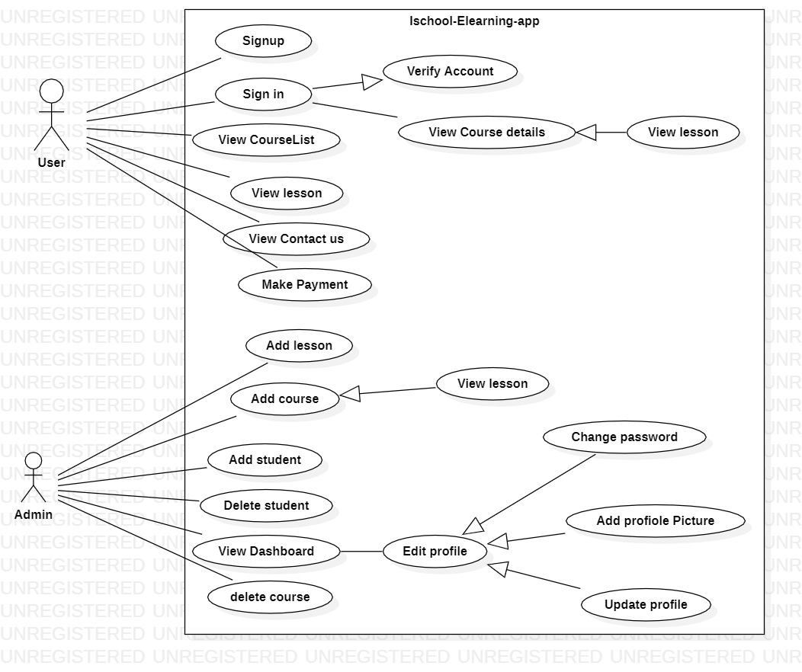

35

* 1. **Class Diagram**

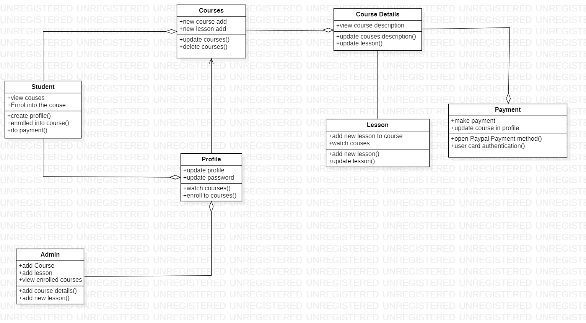

# Activity Diagram

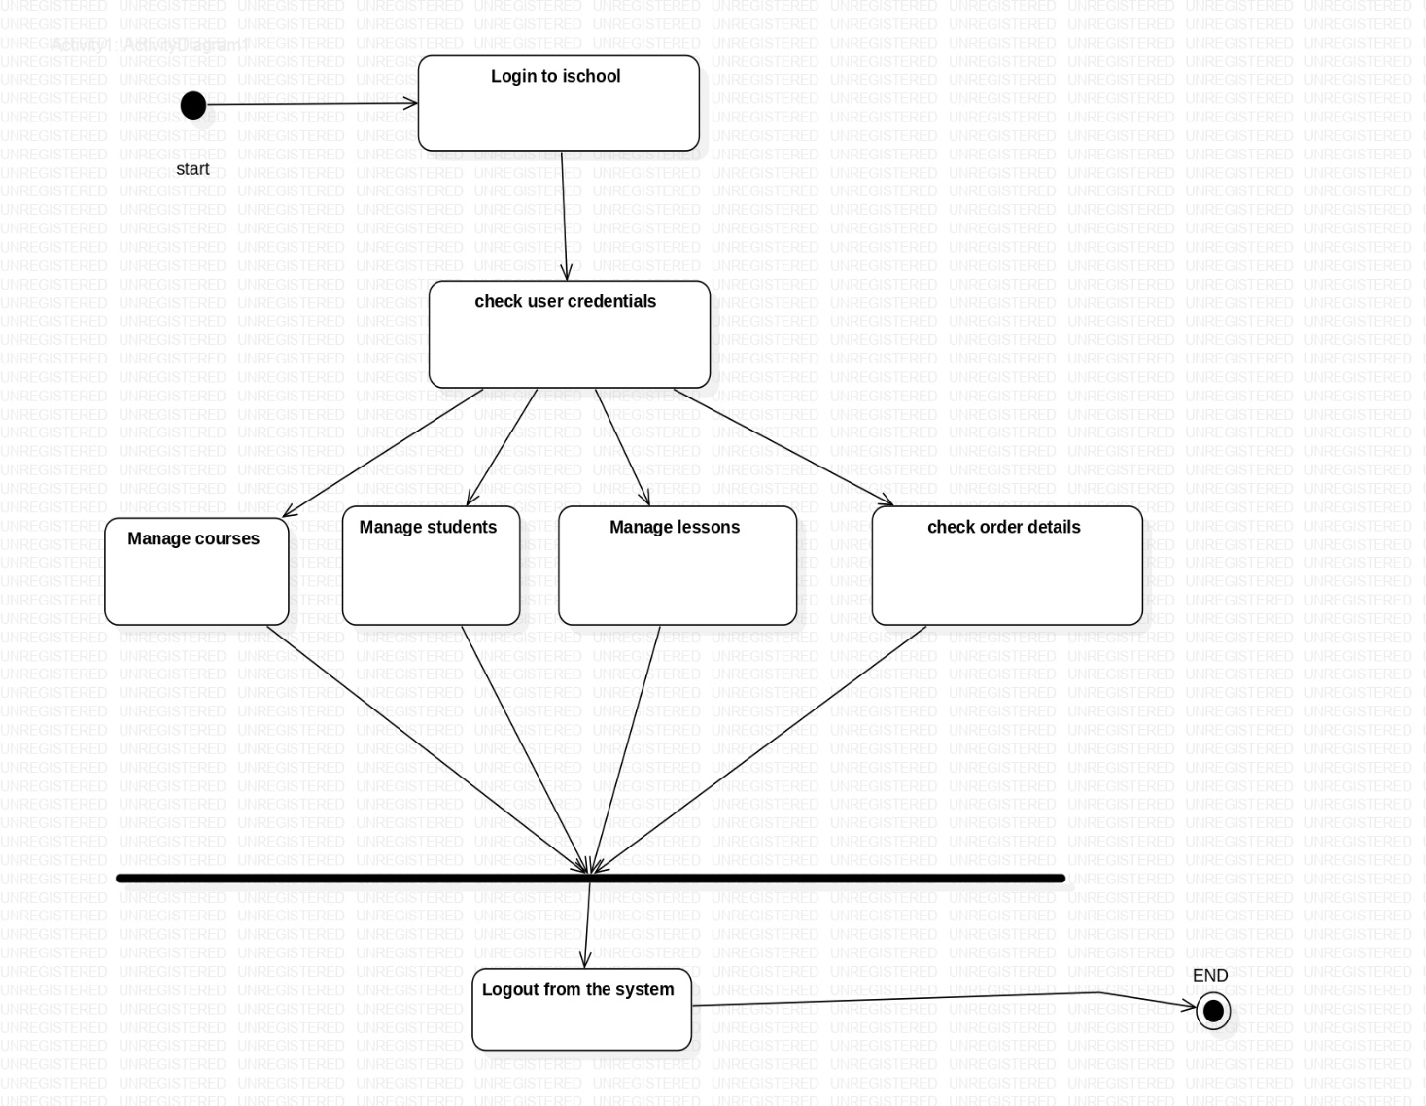

* 1. **Deployment Diagram**

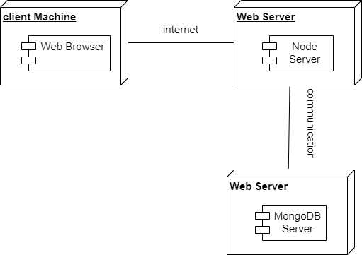

# Module Hierarchy Diagram

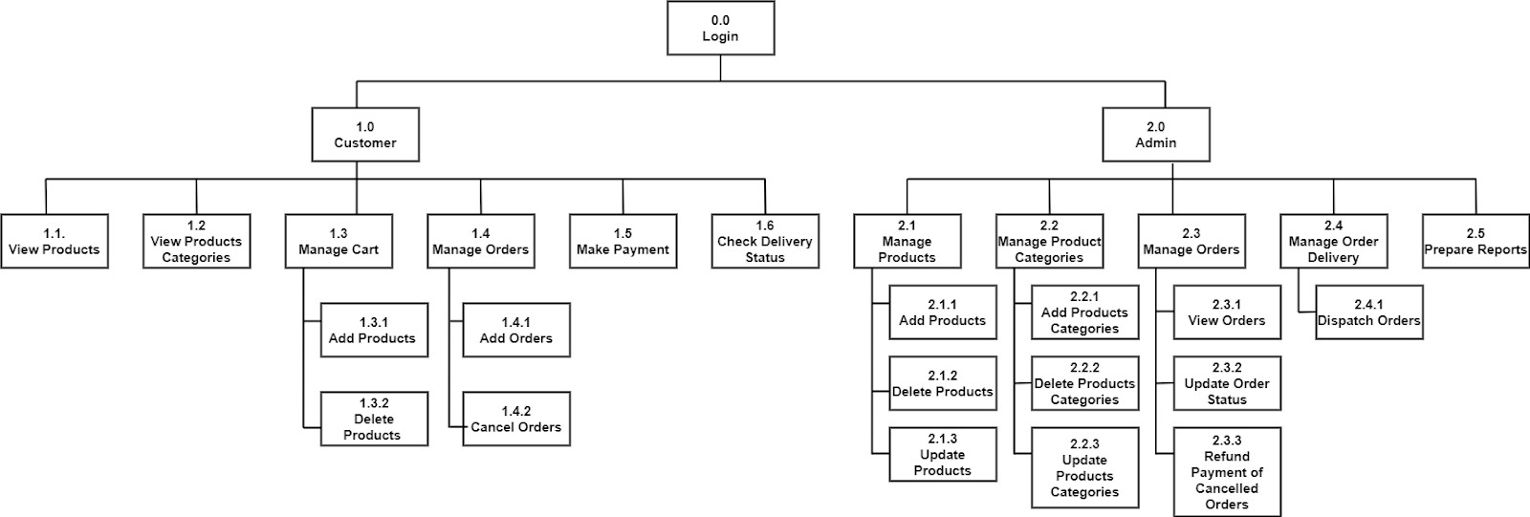

* 1. **Sample Input and Output Screens Customer:**

# Dashboard



**Sign In**

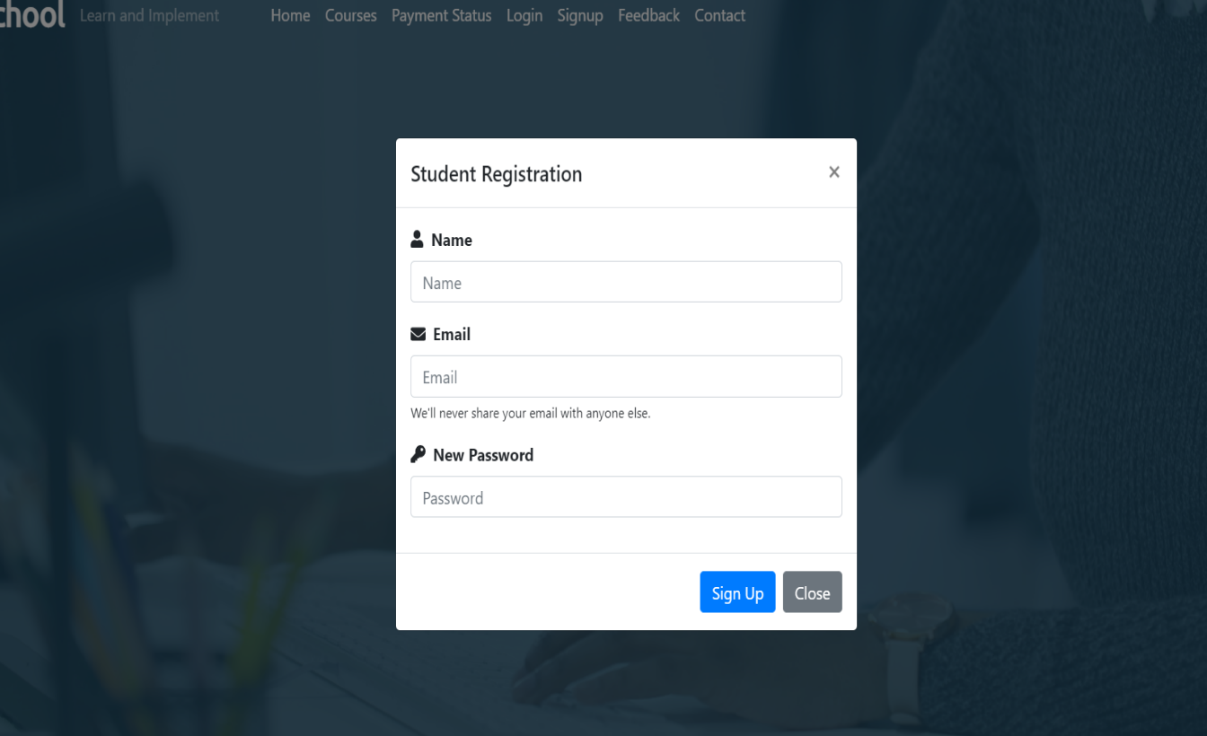

# Profile

**StudentSigned In Dashboard**

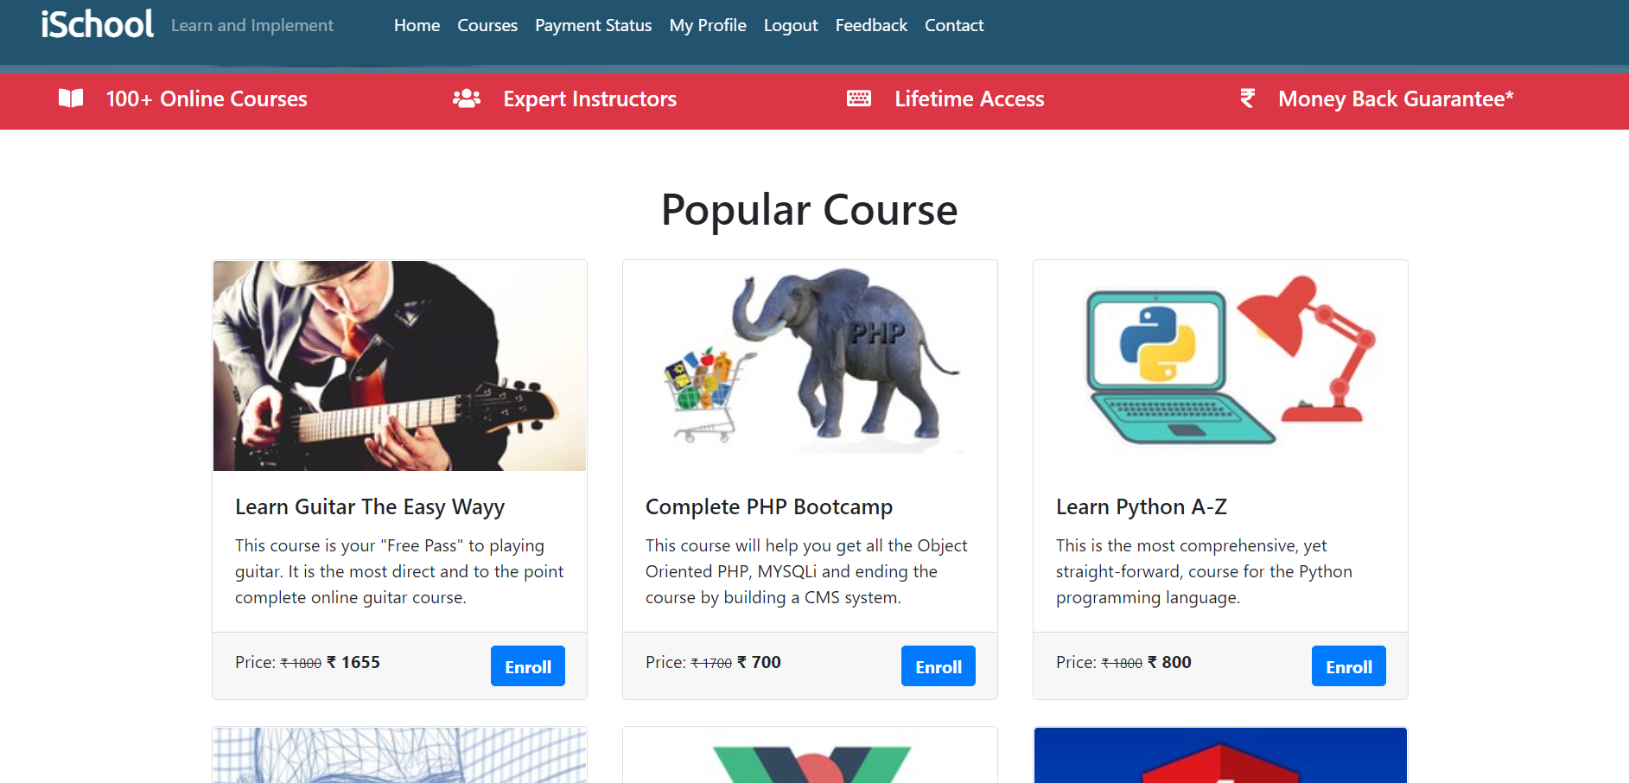

# Admin Details

# 

**Courses**

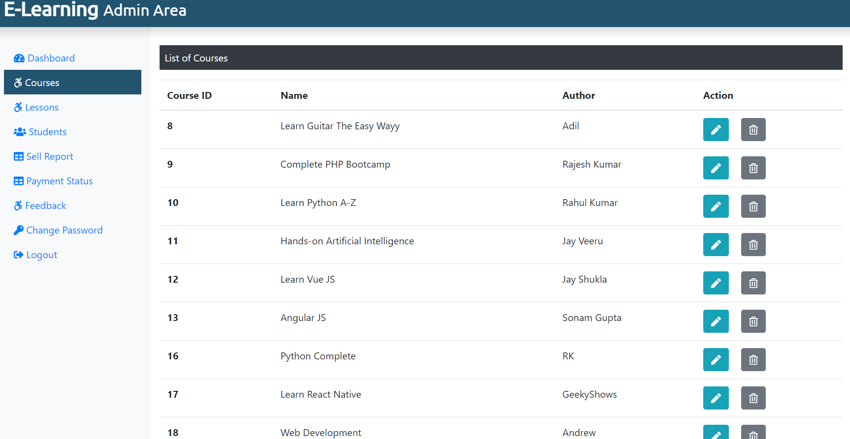

# Shipping Details

**Payment**

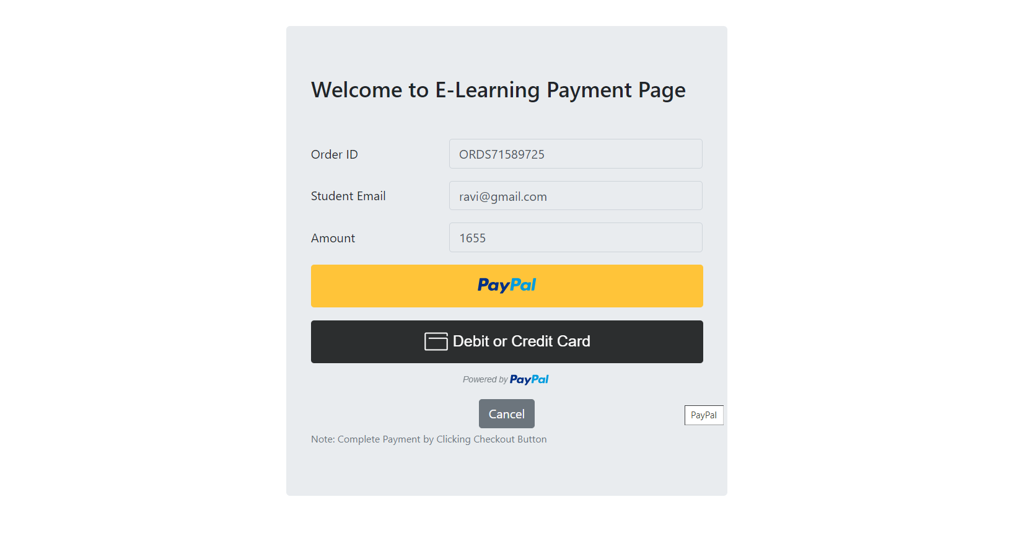

# Place Order

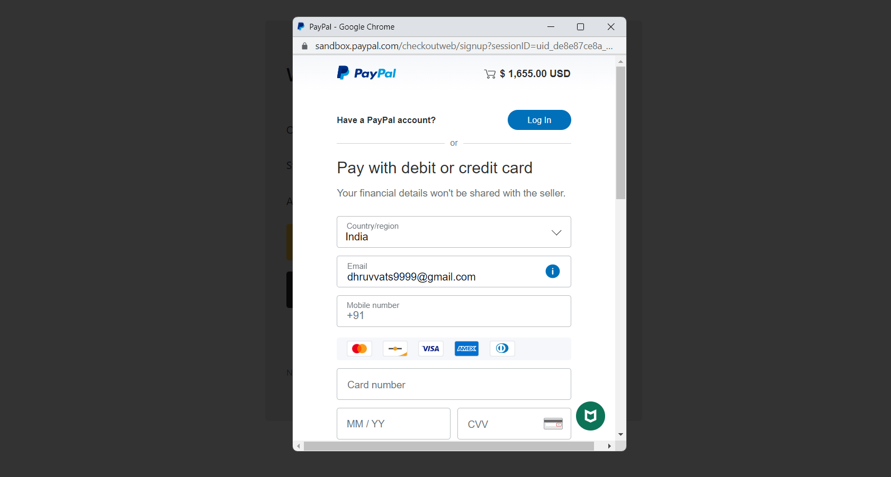

**Order Summary**

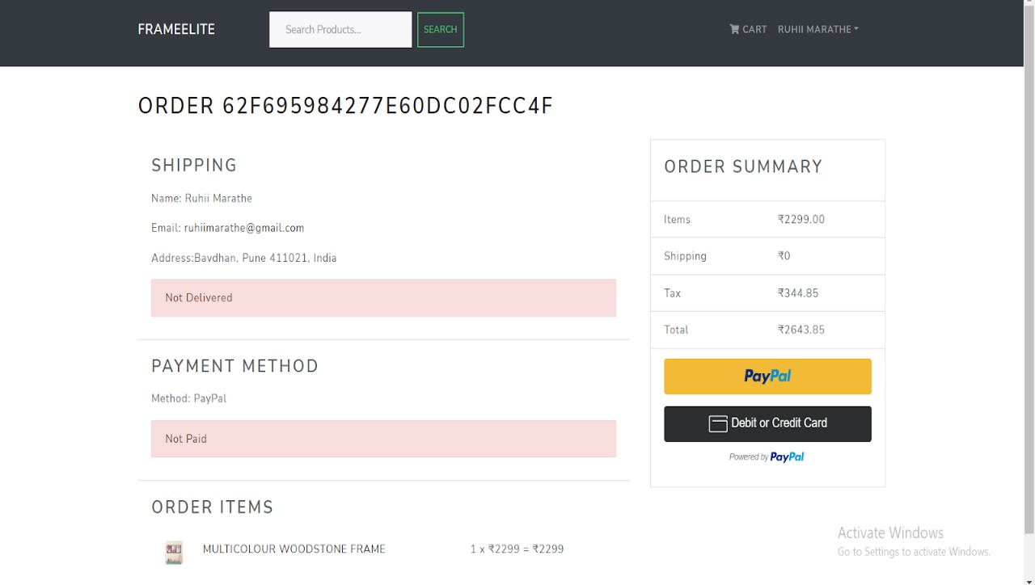

# Paypal

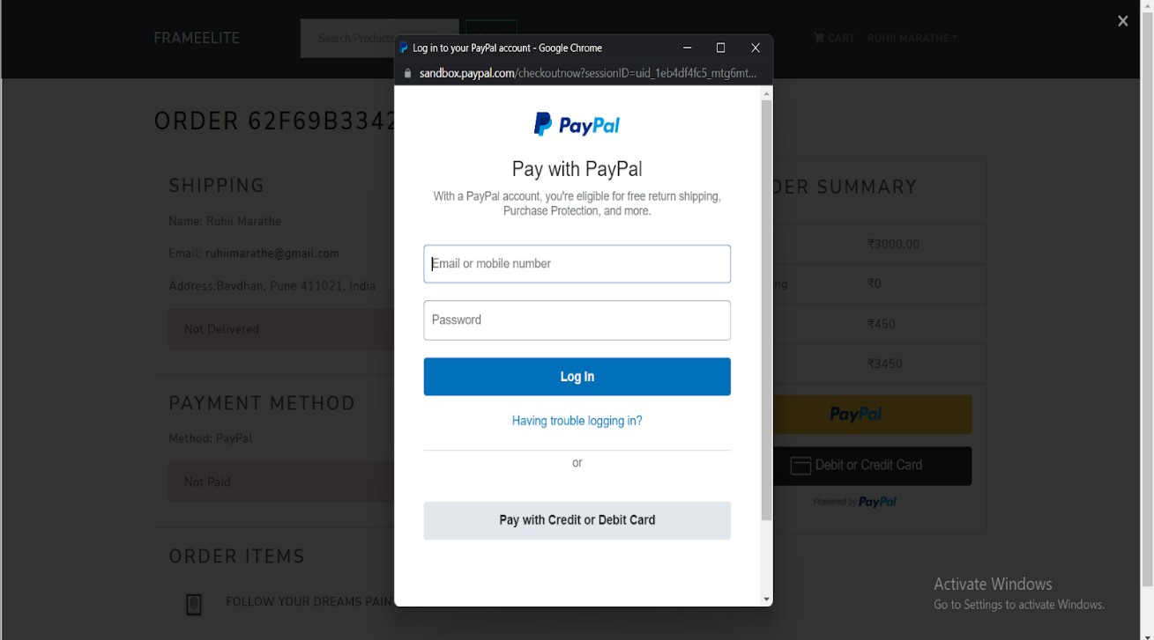

1. **Coding**

# Code Snippets

<?php

  include('./dbConnection.php');

  // Header Include from mainInclude

  include('./mainInclude/header.php');

?>

    <!-- Start Video Background-->

    <div class="container-fluid remove-vid-marg">

      <div class="vid-parent">

        <video playsinline autoplay muted loop>

          <source src="video/banvid.mp4" />

        </video>

        <div class="vid-overlay"></div>

      </div>

      <div class="vid-content" >

        <h1 class="my-content">Welcome to iSchool</h1>

        <small class="my-content">Learn and Implement</small><br />

        <?php

              if(!isset($_SESSION['is_login'])){

                echo '<a class="btn btn-danger mt-3" href="#" data-toggle="modal" data-target="#stuRegModalCenter">Get Started</a>';

              } else {

                echo '<a class="btn btn-primary mt-3" href="student/studentProfile.php">My Profile</a>';

              }

          ?>

      </div>

    </div> <!-- End Video Background -->

    <div class="container-fluid bg-danger txt-banner"> <!-- Start Text Banner -->

        <div class="row bottom-banner">

          <div class="col-sm">

            <h5> <i class="fas fa-book-open mr-3"></i> 100+ Online Courses</h5>

          </div>

          <div class="col-sm">

            <h5><i class="fas fa-users mr-3"></i> Expert Instructors</h5>

          </div>

          <div class="col-sm">

            <h5><i class="fas fa-keyboard mr-3"></i> Lifetime Access</h5>

          </div>

          <div class="col-sm">

            <h5><i class="fas fa-rupee-sign mr-3"></i> Money Back Guarantee*</h5>

          </div>

        </div>

    </div> <!-- End Text Banner -->

    <div class="container mt-5"> <!-- Start Most Popular Course -->

      <h1 class="text-center">Popular Course</h1>

      <div class="card-deck mt-4"> <!-- Start Most Popular Course 1st Card Deck -->

        <?php

        $sql = "SELECT * FROM course LIMIT 3";

        $result = $conn->query($sql);

        if($result->num_rows > 0){

          while($row = $result->fetch_assoc()){

            $course_id = $row['course_id'];

            echo '

            <a href="coursedetails.php?course_id='.$course_id.'" class="btn" style="text-align: left; padding:0px; margin:0px;">

              <div class="card">

                <img src="'.str_replace('..', '.', $row['course_img']).'" class="card-img-top" alt="Guitar" />

                <div class="card-body">

                  <h5 class="card-title">'.$row['course_name'].'</h5>

                  <p class="card-text">'.$row['course_desc'].'</p>

                </div>

                <div class="card-footer">

                  <p class="card-text d-inline">Price: <small><del>&#8377 '.$row['course_original_price'].'</del></small> <span class="font-weight-bolder">&#8377 '.$row['course_price'].'<span></p> <a class="btn btn-primary text-white font-weight-bolder float-right" href="coursedetails.php?course_id='.$course_id.'">Enroll</a>

                </div>

              </div>

            </a>  ';

          }

        }

        ?>

      </div>  <!-- End Most Popular Course 1st Card Deck -->

      <div class="card-deck mt-4"> <!-- Start Most Popular Course 2nd Card Deck -->

        <?php

          $sql = "SELECT * FROM course LIMIT 3,3";

          $result = $conn->query($sql);

          if($result->num_rows > 0){

            while($row = $result->fetch_assoc()){

              $course_id = $row['course_id'];

              echo '

                <a href="coursedetails.php?course_id='.$course_id.'"  class="btn" style="text-align: left; padding:0px;">

                  <div class="card">

                    <img src="'.str_replace('..', '.', $row['course_img']).'" class="card-img-top" alt="Guitar" />

                    <div class="card-body">

                      <h5 class="card-title">'.$row['course_name'].'</h5>

                      <p class="card-text">'.$row['course_desc'].'</p>

                    </div>

                    <div class="card-footer">

                      <p class="card-text d-inline">Price: <small><del>&#8377 '.$row['course_original_price'].'</del></small> <span class="font-weight-bolder">&#8377 '.$row['course_price'].'<span></p> <a class="btn btn-primary text-white font-weight-bolder float-right" href="#">Enroll</a>

                    </div>

                  </div>

                </a>  ';

            }

          }

        ?>

      </div>   <!-- End Most Popular Course 2nd Card Deck -->

      <div class="text-center m-2">

        <a class="btn btn-danger btn-sm" href="courses.php">View All Course</a>

      </div>

    </div>  <!-- End Most Popular Course -->

    <?php

    // Contact Us

    include('./contact.php');

    ?>

     <!-- Start Students Testimonial -->

      <div class="container-fluid mt-5" style="background-color: #4B7289" id="Feedback">

        <h1 class="text-center testyheading p-4"> Student's Feedback </h1>

        <div class="row">

          <div class="col-md-12">

            <div id="testimonial-slider" class="owl-carousel">

            <?php

              $sql = "SELECT s.stu_name, s.stu_occ, s.stu_img, f.f_content FROM student AS s JOIN feedback AS f ON s.stu_id = f.stu_id";

              $result = $conn->query($sql);

              if($result->num_rows > 0) {

                while($row = $result->fetch_assoc()){

                  $s_img = $row['stu_img'];

                  $n_img = str_replace('../','',$s_img)

            ?>

              <div class="testimonial">

                <p class="description">

                <?php echo $row['f_content'];?>

                </p>

                <div class="pic">

                  <img src="<?php echo $n_img; ?>" alt=""/>

                </div>

                <div class="testimonial-prof">

                  <h4><?php echo $row['stu_name']; ?></h4>

                  <small><?php echo $row['stu_occ']; ?></small>

                </div>

              </div>

              <?php }} ?>

            </div>

          </div>

        </div>

    </div>  <!-- End Students Testimonial -->

    <div class="container-fluid bg-danger"> <!-- Start Social Follow -->

        <div class="row text-white text-center p-1">

          <div class="col-sm">

            <a class="text-white social-hover" href="#"><i class="fab fa-facebook-f"></i> Facebook</a>

          </div>

          <div class="col-sm">

            <a class="text-white social-hover" href="#"><i class="fab fa-twitter"></i> Twitter</a>

          </div>

          <div class="col-sm">

            <a class="text-white social-hover" href="#"><i class="fab fa-whatsapp"></i> WhatsApp</a>

          </div>

          <div class="col-sm">

            <a class="text-white social-hover" href="#"><i class="fab fa-instagram"></i> Instagram</a>

          </div>

        </div>

    </div> <!-- End Social Follow -->

    <!-- Start About Section -->

    <div class="container-fluid p-4" style="background-color:#E9ECEF">

      <div class="container" style="background-color:#E9ECEF">

        <div class="row text-center">

          <div class="col-sm">

            <h5>About Us</h5>

              <p>iSchool provides universal access to the world’s best education, partnering with top universities and organizations to offer courses online.</p>

          </div>

          <div class="col-sm">

            <h5>Category</h5>

            <a class="text-dark" href="#">Web Development</a><br />

            <a class="text-dark" href="#">Web Designing</a><br />

            <a class="text-dark" href="#">Android App Dev</a><br />

            <a class="text-dark" href="#">iOS Development</a><br />

            <a class="text-dark" href="#">Data Analysis</a><br />

          </div>

          <div class="col-sm">

            <h5>Contact Us</h5>

            <p>iSchool Pvt Ltd <br> Near Police Camp II <br> Bokaro, Jharkhand <br> Ph. 000000000 </p>

          </div>

        </div>

      </div>

    </div> <!-- End About Section -->

  <?php

    // Footer Include from mainInclude

    include('./mainInclude/footer.php');

  ?>

# Limitation of Proposed System

1. Filtering of frames by colour is not available in this system.
2. Filtering of frames by frame size is not available in this system.
3. Custom-made Photo frames are not available in this system.

# 7. Proposed Enhancement:

1. Cancel Orders
2. Return Orders
3. Custom Made courses
4. Quiz and Test

+

# Conclusion:

All the main requirements of the user have been addressed in this application. Application has two main roles: Student and Admin.

The application has been thoroughly tested. As we know, any project, even on completion, requires constant improvement and changes which gives way for release of new versions.

This application is very user-friendly. For developing the application, technologies such as PHP JavaScript ,Mysql are used which are easy to maintain.

# Bibliography:

## Websites:

* 1. <https://www.mahattaart.com/>
  2. [https://www.udemy.com/course/mern-](https://www.udemy.com/course/mern-ecommerce/learn/lecture/22515124#overview)

[ecommerce/learn/lecture/22515124#overview](https://www.udemy.com/course/mern-ecommerce/learn/lecture/22515124#overview)

* 1. [https://www.youtube.com/watch?v=waB-e0frmTs&list=PLd-](https://www.youtube.com/watch?v=waB-e0frmTs&list=PLd-h3ZCx4fpbJ0LfO7CsMLZd47HGD2FmJ&ab_channel=Courses)

[h3ZCx4fpbJ0LfO7CsMLZd47HGD2FmJ&ab_channel=Courses](https://www.youtube.com/watch?v=waB-e0frmTs&list=PLd-h3ZCx4fpbJ0LfO7CsMLZd47HGD2FmJ&ab_channel=Courses)

* 1. [https://www.youtube.com/watch?v=y66RgYMAgSo&t=1229s&ab](https://www.youtube.com/watch?v=y66RgYMAgSo&t=1229s&ab_channel=LamaDev)

[_channel=LamaDev](https://www.youtube.com/watch?v=y66RgYMAgSo&t=1229s&ab_channel=LamaDev)

* 1. <https://stackoverflow.com/>

# User Manual:

For any system to be successful it is important that the intended user finds the system easy to operate. The purpose of the user manual is to make the user acquainted with the system and help the user understand the system and operate it conveniently. The User Manual is prepared reflexively because it is an item that must accompany every system.

The manual contains several screenshots that describes how to use the entire system. This manual helps user to navigate efficiently through the system and help user to solve issues whenever they occur.

Information about the system:

The system contains the following users:

StudentsAdmin

The system has the following features:

## Customers:

* 1. **Student Registration:** Students can register themselves on the I-School website.
  2. **StudentSign In:** Students can sign in to the I-School website.
  3. **View Photo Frames:** Students can view, search different photo frames.
  4. **View Photo Frames details:** Students can view detailed descriptions of photo frames like price, frame colour, frame size, etc.
  5. **Check if Frames are in stock or not:** Students can check if the photo frame is in stock or not.
  6. **Select Frame Quantity:** Students can select the quantity of photo frames.
  7. **Cart:** Students can add photo frames to the cart.
  8. **View Cart Details**: Students can view their cart details.
  9. **Delete Coursesfrom Cart:** Students can delete the added photo frames from the cart.
  10. **Checkout:** Students can click on the proceed to checkout button.
  11. **Shipping Details:** Students can fill in the shipping details like Address, City, Postal Code, Country, and click on the continue button.
  12. **Payment method:** Students can select the Payment Method.
  13. **Place Order:** Students can view the Shipping details, Payment method, Order items and can click on the Place Order button.
  14. **View Order Summary:** Students can view the order summary.
  15. **Online Payment:** Students can make the payment using Online Payment PayPal by login into the PayPal account or by using Credit or debit card.
  16. **View Payment Status:** Students can view the Payment Status as paid.
  17. **View Orders:** Students can view their orders.
  18. **View, Update Profile:** Students can view their profile, update their profile.
  19. **Reviews:** Students can give reviews to the Photo Frames by selecting ratings and writing a comment.

## Admin:

**Admin Manages Customers:**

1. Admin can view the users of the I-School website.
2. Admin can edit the user details.
3. Admin can assign the role as admin to any customers/users.
4. Admin can delete the users of the I-School website.

## Admin Manages Products:

1. Admin can create a Product by entering name, price, upload image, enter frame colour, frame size, Count In stock, category, description.
2. Admin can edit the product details.
3. Admin can delete the products.

## Admin Manages Orders:

1. Admin can view the orders, order details.
2. Admin can Mark the order as delivered.